SOAS ERP SYSTEM
User Manual
━━━━━━━━━━━━━━━━━━━━━━━━━━━━━━━━━━━━━━━━━━━━
Entity Dashboard · Quick Actions · Money & Banking
Operations · Inventory Management · Reports & Insights · Accounting & Setup

Version 3.1
February 2026
Django Ledger SOAS ERP — Main Application

For users of the main SOAS ERP entity dashboard (not the Admin UI)

TABLE OF CONTENTS

Quick Finder
Use the table below to jump directly to any common task. Bold text shows the exact sidebar path to use.

I want to… | Sidebar Path | Section
Log in and open the application | — | 2.1 Logging In
Switch or create my entity | My Entities (sidebar bottom) | 2.2 – 2.3
Add or edit Chart of Accounts | Accounting & Setup > Chart of Accounts | 3.1
Create a manual journal entry | Accounting & Setup > Journals | 3.2
Create a closing entry | Accounting & Setup > Closing Entries | 3.3
Add a customer | Quick Actions > Customers | 4.1
Create an invoice | Quick Actions > Invoices | 4.2
Record a customer payment | Invoice detail > Add Payment | 4.2
Create a credit note | Money & Banking > Credit Note | 4.3
View receipts | Money & Banking > Receipt | 4.4
Add a supplier | Quick Actions > Suppliers | 5.1
Create a bill | Quick Actions > Bills | 5.2
Record a bill payment | Bill detail > Add Payment | 5.2
Create a purchase order | Operations > Purchase Orders | 5.3
Record goods received | Operations > Goods Receipt | 5.3
Create a debit note | Money & Banking > Debit Note | 5.4
Add a product | Inventory Management > Products & Items > Products | 6.1
Add a service | Inventory Management > Products & Items > Services | 6.1
Manage stock / inventory items | Inventory Management > Products & Items > Inventory Items | 6.2
Add bank or cash account | Money & Banking > Bank / Cash | 7.1
Reconcile bank account | Money & Banking > Bank Reconciliation | 7.2
View payments dashboard | Money & Banking > Payment Dashboard | 7.2
Run Balance Sheet | Reports & Insights > Balance Sheet | 8
Run Income Statement | Reports & Insights > Income Statement | 8
Run Cash Flow Statement | Reports & Insights > Cash Flow Statement | 8
Change profile or settings | User menu (top-right) | 9
Fix login or balance issues | — | 10 Troubleshooting

1. Introduction

Welcome to SOAS ERP (Django Ledger SOAS ERP). This manual covers the main application — the entity dashboard you see after logging in — using the exact sidebar labels: Entity Dashboard, Quick Actions, Money & Banking, Operations, Inventory Management, Reports & Insights, and Accounting & Setup. Every step in this manual matches what you see on screen.

ℹ NOTE: This manual covers the main application. If your organization also uses the Admin UI (at /admin-ui/), the sidebar labels there are different (Dashboard, Entity, Accounting, Sales, Purchases, etc.). The tasks are similar but use the labels you see in whichever interface you are working in.

1.1 What You See in the Sidebar
Your sidebar depends on your role and permissions. The sections below show what is typically available:

Sidebar Section | What It Contains
Entity Dashboard | Your main dashboard for the current entity — overview widgets, key metrics, and quick links.
Quick Actions | Invoices, Bills, Customers, Suppliers, Products, Employees — shortcuts to the most common daily tasks.
CRM | Prospects, Pipeline Board, CRM Analytics (if enabled for your role).
Money & Banking | Bank / Cash, Payment Dashboard, Receipt, Credit Note, Debit Note, Bank Reconciliation.
Expenses | Expense Management Dashboard, Expense Reports, Expense Claims, Expense Categories, Expense Payments, Payment Requests, Recurring Payments, Business Expenses.
Operations | Purchase Orders, Goods Receipt, Inventory Items, Stock Transactions, Warehouses, Service Projects, Services.
Inventory Management | Overview & Monitoring; Products & Items (Products, Services, Inventory Items, Categories, Unit of Measures); Stock Management; Warehouse Operations; Reports & Analytics.
People & Payroll | HRM, Payroll, Attendance, Expense Claims (if enabled).
Reports & Insights | AI Assistant, Analytics, Reports, Balance Sheet, Income Statement, Cash Flow Statement, and related reports.
Accounting & Setup | Chart of Accounts, Journals, Tax Rates, Closing Entries, Period Locks, Budget, OHADA Compliance.
Advanced | Recurring Invoices, Batch Invoices, Customer Deposits, AI Inventory, and other advanced features.
Administration | Entity administration and configuration.
My Entities | Switch or manage your entities (at the bottom of the sidebar).
Subscriptions | Your subscriptions (at the bottom of the sidebar).

ℹ NOTE: Your menu may show fewer or more items depending on your role and permissions. If a section is not visible, you do not have permission to access it — contact your administrator.

1.2 Document Conventions
Convention | Meaning | Example
Bold | Exact button, menu item, or field label you see on screen | Click Save Invoice
Italic | First use of an important term | An entity is one company
Path > Like > This | Sidebar navigation path | Quick Actions > Invoices
TIP callout | Shortcut or recommended practice | Green boxes throughout
WARNING callout | Action that affects data or security — read before proceeding | Red boxes throughout
NOTE callout | Extra clarification for a step or option | Blue boxes throughout
SIDEBAR PATH callout | Exact sidebar path to navigate before the steps begin | Orange boxes throughout

1.3 System Requirements
Requirement | Specification
Browser | Current version of Chrome, Firefox, Safari, or Edge
Connection | Reliable internet (cloud-hosted deployment)
Screen | 1920×1080 or higher recommended
Access | A user account created and permissions assigned by your administrator

1.4 Screenshots
This manual includes screenshot placeholders in the format [Screenshot: description — docs/screenshots/filename.png]. To add a real screenshot: (1) Capture the relevant screen. (2) Save it to docs/screenshots/ using the suggested filename. (3) Replace the placeholder text with a Markdown image reference in your documentation tool.

2. Getting Started
This section takes you from first login through selecting or creating an entity and completing basic setup. Work through these steps in order if you are new.

2.1 Logging In
Before you begin: You need a user account. Your administrator provides the login URL and your credentials.

1 | Open the login page. Go to the URL provided by your organization (e.g., the main site login or /admin/ for Django Admin).

2 | Enter your username and password. Passwords are case-sensitive. Use the username provided by your administrator, not necessarily your email address.

3 | Click Log in or Sign in.

4 | You are taken to the main application (entity dashboard). If you see the Admin UI instead, use the link or menu your organization provides to navigate to the entity dashboard.

💡 TIP: If your organization uses single sign-on (SSO), click Log in with SSO and follow your identity provider's prompts.
ℹ NOTE: If you cannot log in, see Section 10.1: Can't Log In for a complete troubleshooting checklist.

2.2 Switching Entity
The application always operates in the context of one entity (one company or business unit). Before entering data, confirm you are working in the correct entity.

1 | Check the current entity. The page title or header shows the current entity name (e.g., 'Acme Corp | Dashboard').

2 | In the sidebar, scroll to the bottom and click My Entities. Choose the entity you want to work in. The dashboard and all sidebar links then apply to that entity.

3 | If only one entity appears, ask your administrator to assign you to additional entities or to create a new one.

⚠ WARNING: Always verify the entity name in the header before entering data. Records created in the wrong entity cannot be automatically moved.

2.3 Setting Up Your First Entity
Before you begin: Gather your company's legal name, tax ID, fiscal year start month, base currency, and full business address.

Creating an Entity
▶ SIDEBAR PATH: My Entities (sidebar bottom) > Create Entity

1 | In the sidebar, click My Entities at the bottom of the menu.

2 | Click Create Entity or Add Entity. (On first-time setup, you may see an onboarding wizard — follow it.)

3 | Complete the entity form:

Field | Description | Example
Name | Day-to-day name used in the interface | Acme Corp
Legal Name | Official registered name for contracts and tax | Acme Corporation Ltd.
Tax ID | Government tax identification number | 123-456-789
Address | Full address (street, city, region, postal code, country) | 12 Main St, Nairobi, KE
Phone | Main business contact number | +254 20 000 0000
Email | Main business email | accounts@acme.com
Fiscal Year Start | First month of your financial year | January
Base Currency | Primary reporting currency | XAF, USD, EUR

4 | Click Save Entity to finalize, or Save Draft to save without finalizing.

ℹ NOTE: After saving, use My Entities to switch to the new entity. All subsequent work — Chart of Accounts, Customers, Invoices, etc. — operates in the selected entity context.
⚠ WARNING: Set fiscal year and base currency correctly at creation. Changing them after transactions have been entered is disruptive and may require administrator assistance.

Company Settings and Administration
- Company Settings — In the sidebar, click Company Settings to configure the entity: accounting standards, number/date format, time zone, multi-currency, and other options.
- Administration — Click Administration in the sidebar to manage entity-level users and security. Access depends on your permissions.

2.4 User Roles and Permissions
Access is controlled by permissions assigned by your administrator. The sidebar only shows menu items your account has permission to access.

Capability Area | Sidebar Location | Includes
Entity | My Entities, Company Settings, Administration | Create/switch entities, configure settings, manage users.
Quick Actions | Quick Actions | Invoices, Bills, Customers, Suppliers, Products, Employees.
Money & Banking | Money & Banking | Bank / Cash, Payment Dashboard, Receipt, Credit Note, Debit Note, Bank Reconciliation.
Operations | Operations | Purchase Orders, Goods Receipt, Inventory Items, Stock Transactions, Warehouses, Service Projects.
Inventory | Inventory Management > Products & Items | Products, Services, Inventory Items, Categories, Unit of Measures.
Reports | Reports & Insights | Balance Sheet, Income Statement, Cash Flow Statement, Analytics.
Accounting | Accounting & Setup | Chart of Accounts, Journals, Tax Rates, Closing Entries, Period Locks, Budget.

3. Accounting & Setup
This section covers the Chart of Accounts, Journals, tax rates, Closing Entries, periods locks, Budget management and OHADA Compliance. Access these from Accounting & Setup in the sidebar. Use these for adjustments, corrections, and period-end close. For daily sales and purchases, use Invoices and Bills — they create the journal entries automatically.

3.1 Chart of Accounts Management
The Chart of Accounts (COA) is the complete list of every account your entity uses. Every transaction posts to one or more accounts. Keeping the COA organized makes reporting accurate and easy to read.

▶ SIDEBAR PATH: Accounting & Setup > Chart of Accounts

Opening the Chart of Accounts
1 | In the sidebar, go to Accounting & Setup and click Chart of Accounts.

2 | Verify the entity shown in the page header is correct before making any changes.

Creating an Account
1sss | Click Add Account (label may also appear as Create or New Account).  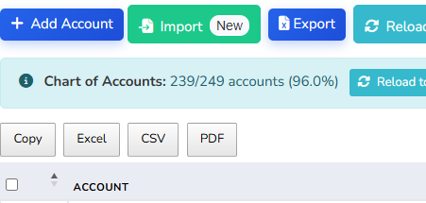

2 | Complete the form:  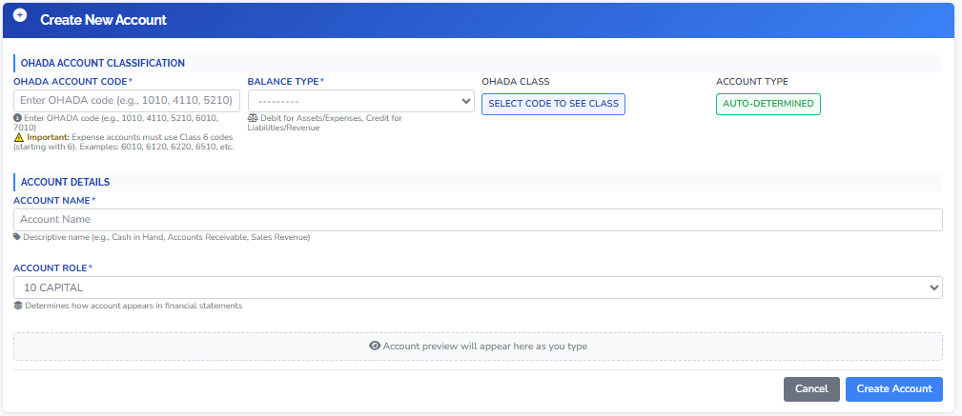

Field | Description | Guidance
Account Code | Unique code (e.g., 1050, 6010) | Leave gaps for future additions: 1000–1999 assets, 2000–2999 liabilities, etc.
Account Name | Clear, descriptive label | e.g., Bank – Payroll, Rent Expense – Office.
Account Type | Asset, Liability, Equity, Income, Expense | Determines which financial statement the account appears on. Cannot be changed after transactions exist.
Parent Account | Leave blank for top-level account | Select a parent to create a sub-account (e.g., parent: Bank; child: Bank – Checking).
Description | Optional internal note | Useful for teams with multiple bookkeepers.
Active | Keep checked to use the account | Uncheck to retire an account without deleting its history.

3 | Click Save or Save Account. The account appears in all account dropdowns.

💡 TIP: Do not create a separate account for every customer or supplier. Use the Accounts Receivable and Accounts Payable accounts and link transactions to the specific customer or supplier.

Editing an Account
1 | Find the account in Accounting & Setup > Chart of Accounts and click its name or Edit.

2 | Change Account Name, Description, or Parent Account as needed.

3 | Click Save.

ℹ NOTE: Avoid changing the Account Code on accounts that already have transactions — reports may depend on this value. Accounts with transactions cannot be deleted; mark them Inactive instead so they disappear from dropdowns but remain in history.

Account Types at a Glance
Type | What It Represents | Examples | Normal Balance | Financial Statement
Asset | Resources owned by the business | Cash, A/R, Inventory, Equipment | Debit | Balance Sheet
Liability | Obligations owed by the business | A/P, Loans, Tax Payable | Credit | Balance Sheet
Equity | Owner's net interest | Share Capital, Retained Earnings | Credit | Balance Sheet
Income | Revenue earned | Sales, Service Revenue, Interest | Credit | Income Statement
Expense | Costs incurred | Rent, Salaries, Utilities, COGS | Debit | Income Statement

3.2 Journals
Journals (journal entries) are the standard way to record adjustments, depreciation, inter-account transfers, and corrections. For daily sales and purchases, use Invoices and Bills — they generate the entries automatically.
Key rule: Every journal entry must have at least one debit line and one credit line. Total debits must equal total credits.

▶ SIDEBAR PATH: Accounting & Setup > Journals

Creating a Manual Journal Entry
1 | Go to Accounting & Setup > Journals and click New Journal Entry (or Create Journal Entry).  To create a new journal example; Purchase journal, sales journal or cash journal.  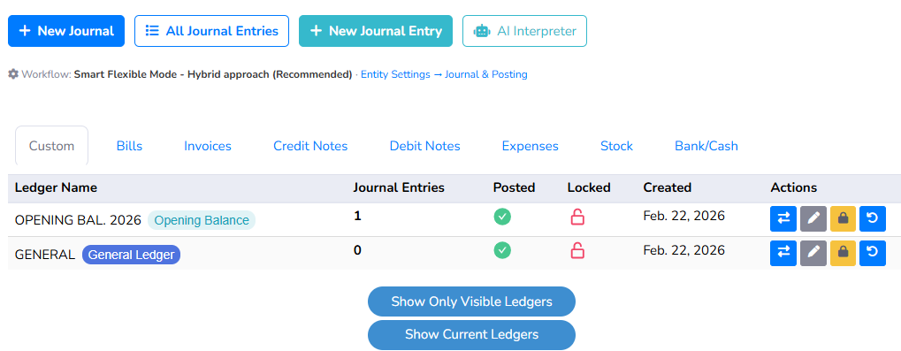

2 | Complete the header:  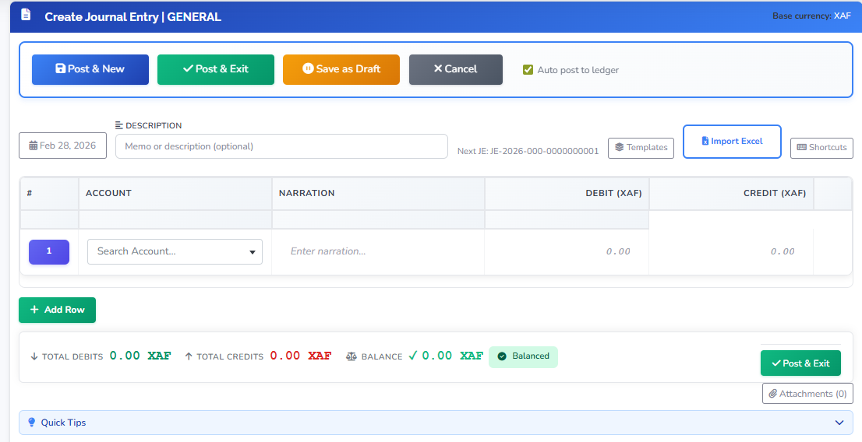

Field | Description
Date | Transaction date — determines the reporting period this entry falls in.
Reference | Optional internal code (e.g., ADJ-001, DEC-DEPR).
Description | Short explanation visible in the general ledger (e.g., Monthly depreciation — Office equipment).

3 | Add at least two lines. For each line, select an Account and enter an amount in either Debit or Credit (not both).

4 | Verify the totals row shows zero difference (Total Debits = Total Credits). The system may display 'Out of balance' until they match.

5 | Click Save to keep as a draft, or Save and Post (if available) to finalize and update account balances.

Example — Recording Monthly Depreciation
Line | Account | Debit | Credit
1 | Depreciation Expense – Office Equipment | 500.00
2 | Accumulated Depreciation – Office Equipment |  | 500.00
 | TOTAL | 500.00 | 500.00

⚠ WARNING: Do not delete a posted journal entry. Create a reversing entry (same accounts and amounts, debits and credits swapped) or a correcting entry instead. This preserves the audit trail.

3.3 Tax Rate

Tax rates are essential for accurate financial reporting compliance and strategics financial management the taxe rate show the total taxrate, active tax rate and inactive tax rate in a business

Go to Accounting & Setup > Journals and click tax rate

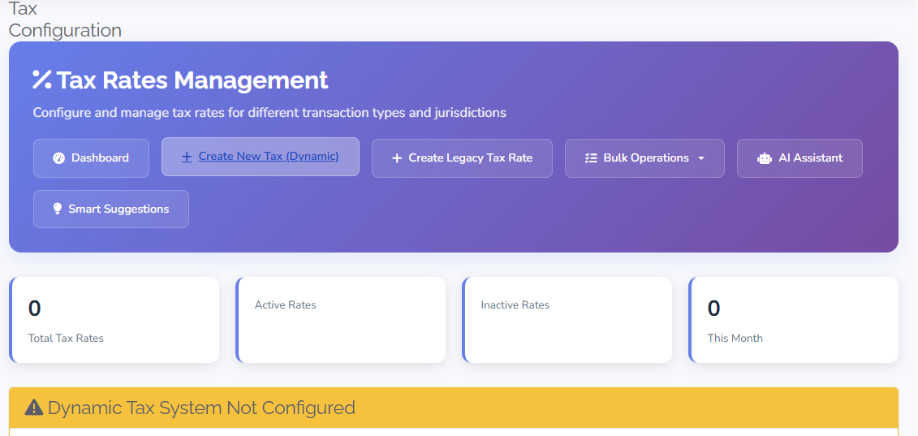

3.4 Closing Entries

Closing entries close revenue and expense accounts at the end of a period (month or year) and transfer net income to retain earnings
▶ SIDEBAR PATH: Accounting & Setup > Closing Entries

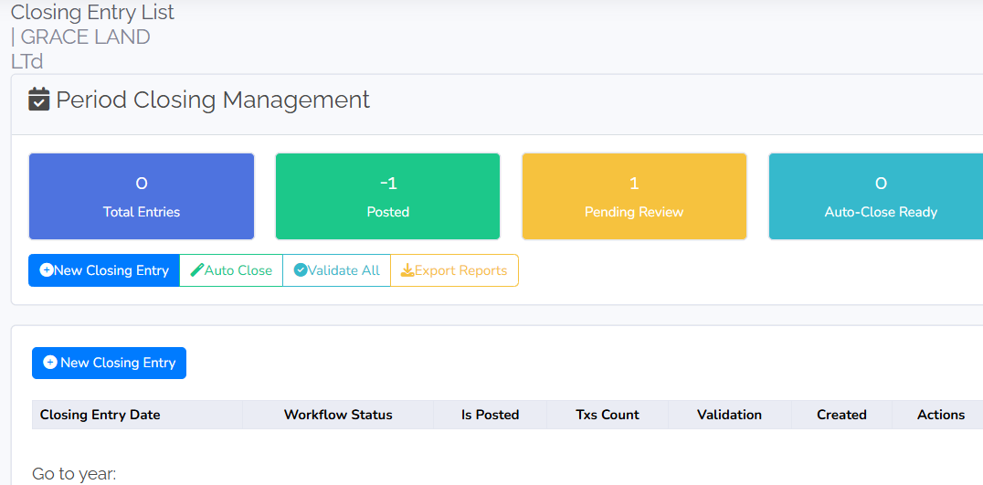

1 | Go to Accounting & Setup > Closing Entries.

2 | Review the list. Create a closing entry by clicking Add Closing Entry (or run a period close, as supported by your installation).

3 | Confirm the period is correct before posting.

⚠ WARNING: Closing a period may lock it, preventing further entries. Ensure all transactions for the period are entered and reviewed before running closing entries.

3.5 Period of Lock

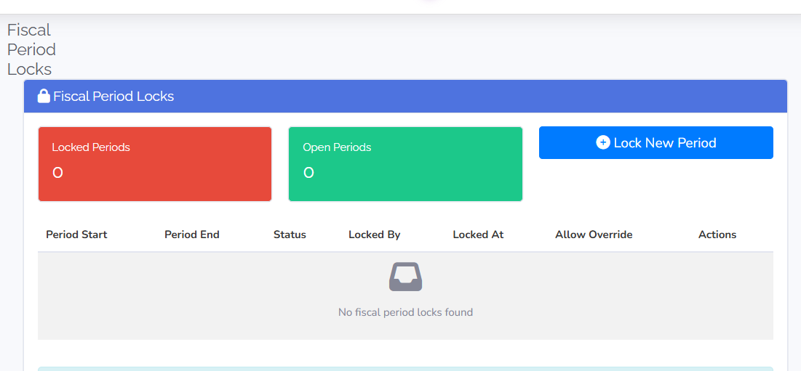

3.6 Budget Management

Budget management involves planning, monitoring, and controlling financial resources to achieve personal or organizational goals. This sections involves; budget dashboard, Budget list, create budget, budget builder, pending budget and AI features

1 | Go to Accounting & Setup > Budget Management

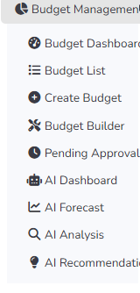

3.7 OHADA Compliance
OHADA compliance refers to adherence to the legal framework established by the OHADA treaty which aims to harmonize business laws among its member states in Africa.

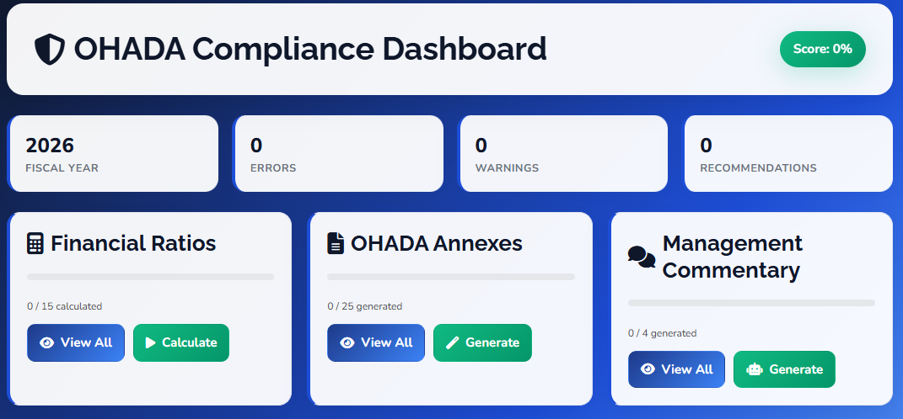

4. Quick Actions
This section covers ,invoices, Bills, Customers, Supplier, Product and Employees. . Use Quick Actions for fast access to Invoices and Customers; use Money & Banking for Credit Note and Receipt. Work in this order: add the customer first, then create the invoice, then record the payment.

4.1 Customer Management
Before you begin: Have the customer's full name (or company name), email address, and billing address.

▶ SIDEBAR PATH: Quick Actions > Customers

Adding a Customer

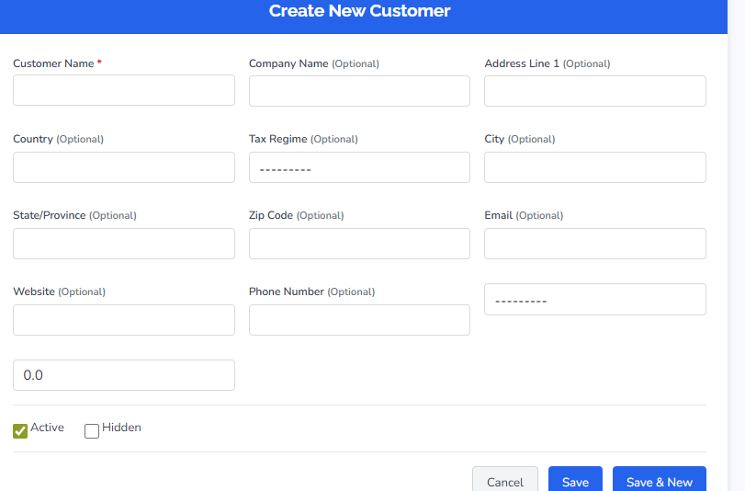

1 | In the sidebar, go to Quick Actions and click Customers.

2 | Click Add Customer.

3 | Complete the customer form:

Field | Description | Required
Customer Name | Full name or company name (e.g., ABC Ltd, John Smith) | Yes
Company Name | If the contact is a person but the bill goes to a company | No
Email | For sending invoices and payment reminders | Yes
Phone | Contact number | No
Billing Address | Street, city, region, postal code, country — appears on all invoices | Yes
Payment Terms | Default due-date rule (e.g., Net 30, Net 60, Due on Receipt) | No
Tax ID | Customer's tax number (required for tax-exempt B2B customers) | No
Currency | Invoice currency for this customer (requires multi-currency enabled) | No

4 | Click Save Customer or Save Draft.

💡 TIP: Use a consistent naming format (e.g., always company name for B2B) so search and reports return predictable results.

Editing or Viewing a Customer
1 | Go to Quick Actions > Customers and click the customer name or Edit.

2 | Make changes on the detail page. Click Save Customer or Save Draft when done. Click Back to List to return without saving.

4.2 Invoices
An invoice is the formal bill you send to a customer. It increases Accounts Receivable and Sales (and Tax Payable where applicable). Record invoices promptly to keep revenue and receivables current.
Before you begin: The customer must exist. Know which products or services to bill, quantities, and prices.

▶ SIDEBAR PATH: Quick Actions > Invoices

Creating an Invoice
1 | In the sidebar, go to Quick Actions and click Invoices.

2 | Click Add Invoice.

3 | Select the Customer. Billing address and payment terms default from the customer record.

4 | Set the invoice details:

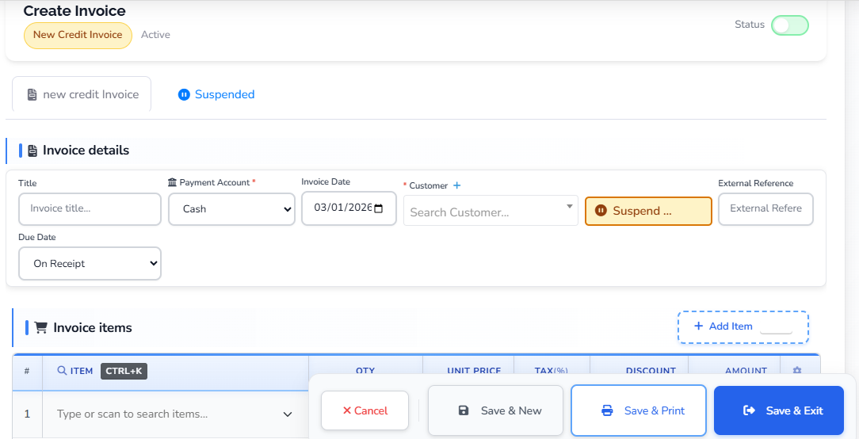

Field | Description
Invoice Date | Date of the invoice — determines the reporting period.
Due Date | Payment deadline — often set automatically from customer Payment Terms.
Invoice Number | Usually auto-generated. Override only if your process requires it.
PO Number | Customer's purchase order reference number (optional).

5 | Add line items:
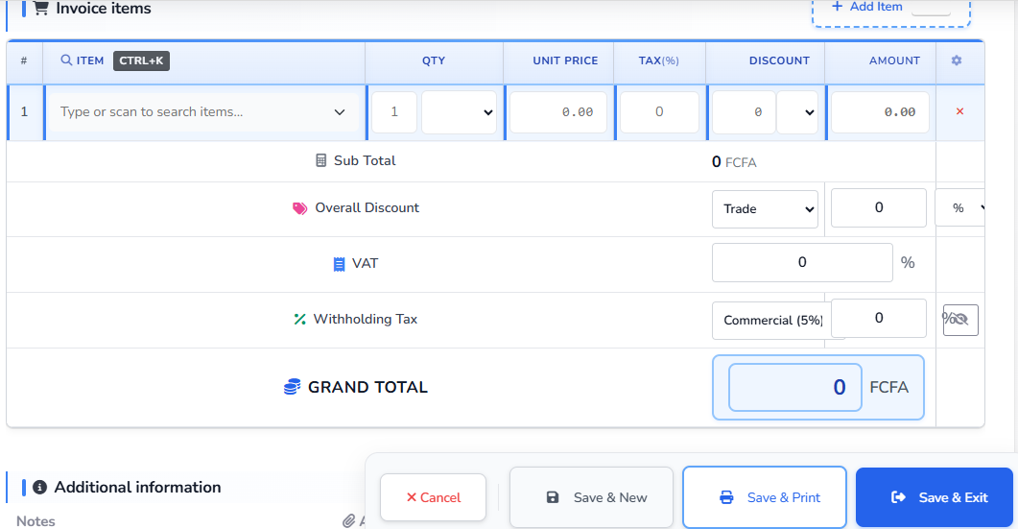

Field | Description
Item / Product | Select from your products or services list, or type a free-text description.
Quantity | Number of units.
Rate | Price per unit.
Tax | Applicable tax rate (if configured for this item or entity).
Discount | Optional percentage or fixed amount per line.

6 | Add any Shipping, Handling, or Other charges if the form includes them.

7 | Review subtotal, tax, and total. Click Save Invoice or Save Draft.

💡 TIP: Use Save Invoice (not Save Draft) so the invoice is finalized and appears in Accounts Receivable immediately.

Recording a Customer Payment
1 | Open the invoice from Quick Actions > Invoices and click into the invoice detail page.

2 | Click Add Payment (or Record Payment) on the invoice detail page.

3 | Enter the payment details:

Field | Description
Payment Date | Date the payment was received.
Amount | Amount received. Can be a partial payment.
Payment Method | Cash, Bank Transfer, Credit Card, Cheque, etc.
Reference | Cheque number, transaction ID, or other reference.
Bank Account | The bank or cash account where the money was deposited.

4 | Save. The invoice balance decreases. When total payments equal the invoice total, the invoice is marked Paid.

ℹ NOTE: You can record multiple partial payments against one invoice. The system tracks the running balance automatically. View receipts linked to payments under Money & Banking > Receipt.

4.3 Bills
A bill is a document that details a transaction and request pament for goods or services provided.

▶ SIDEBAR PATH: Quick Action > Bills

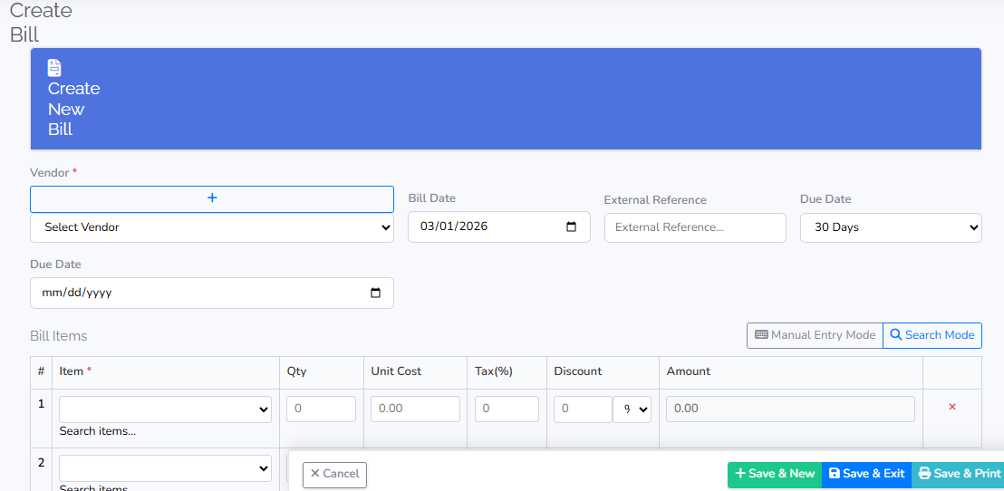
1 | In the sidebar, go to Quick action and click Bills

2 | Click Add Bills.

3 | Key in the necessary information

4 | Select vendor

5 | Add line items with the amounts to bill

6 | Click Save or Save Draft.

4.4 Suppliers

1 | In the sidebar, go to Quick Actions and click Suppliers

2 | Click Add Suppliers

3 | Complete the Suppliers form:

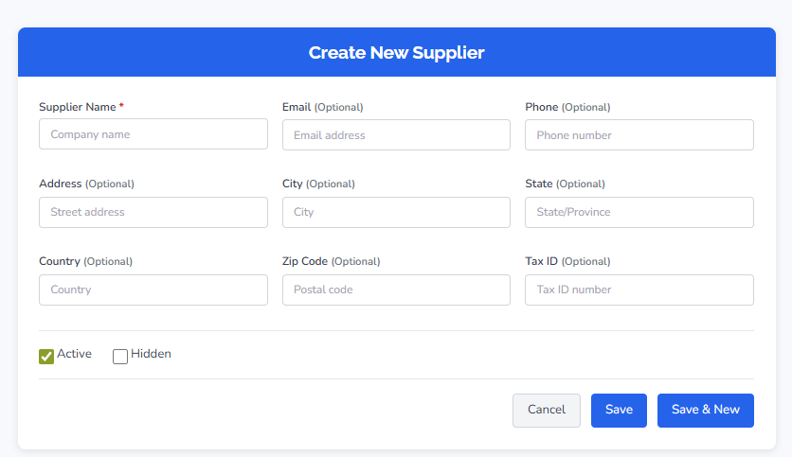
Field | Description | Required
Suppliers Name | Full Suppliers name (e.g., John Smith) | Yes
Company Name | If the contact is a person but the bill goes to a company | No
Email | For sending invoices and payment reminders | Yes
Phone | Contact number | No
Payment Terms | Default due-date rule (e.g., Net 30, Net 60, Due on Receipt) | No
Tax ID | Customer's tax number (required for tax-exempt B2B customers) | No
Currency | Invoice currency for this customer (requires multi-currency enabled) | No

4 | Click Save Supplier or Save Draft.

💡 TIP: Use a consistent naming format (e.g., always company name for B2B) so search and reports return predictable results.

Editing or Viewing a Suppliers
1 | Go to Quick Actions > Suppliers and click the Suppliers name or Edit.

2 | Make changes on the detail page. Click Save Suppliers or Save Draft when done. Click Back to List to return without saving.

4.5 Products

Products refers to the goods or services that a business offers for sale
1 | In the sidebar, go to Quick action and products

2 | Click Add products

3 | Key in the necessary information

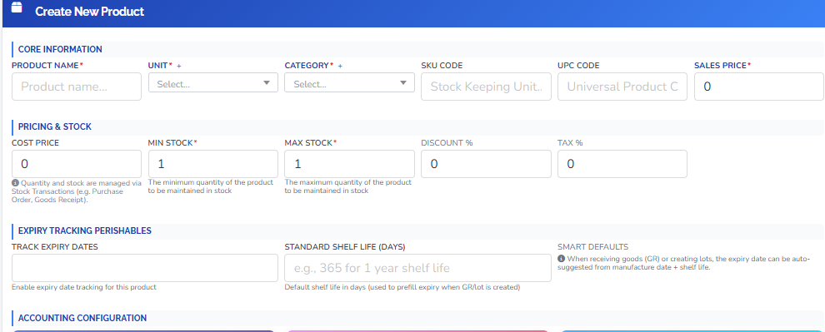

4.6 Employees
Employees refers to the individuals who work for a business or organization in exchange for compensation typically in the form of wages or salaries
1 | In the sidebar, go to Quick action and employees

2 | Click Add employees

3 | Key in the necessary information
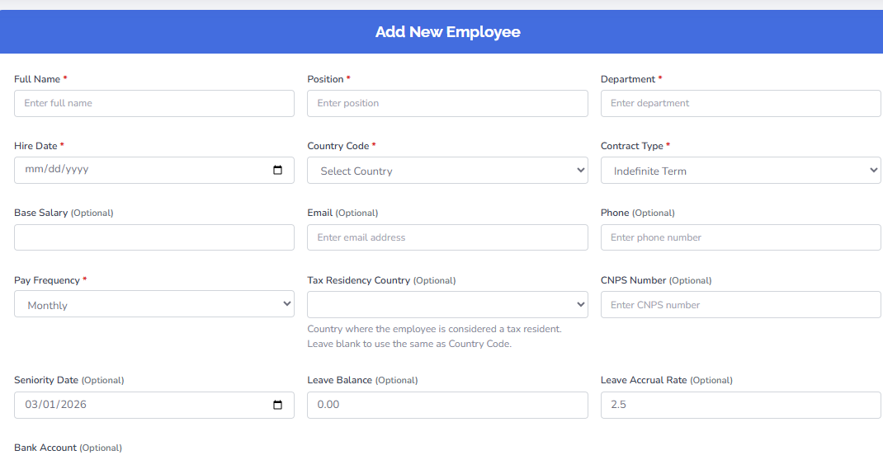

5. Operations
This section covers Purchase orders, Goods Receive, bill of material, inventory item, stock transactions warehouses, and service projects Use Quick Actions for Suppliers and Bills; use Operations for Purchase Orders; Accurate purchase data ensures correct payables, cost reporting, and inventory.

5.1 Purchase Orders
A purchase order (PO) is your formal commitment to buy from a supplier. Send it to the supplier; when goods arrive, record a Goods Receipt; when the supplier's invoice arrives, create a bill.

▶ SIDEBAR PATH: Operations > Purchase Orders

Creating a Purchase Order
1 | In the sidebar, go to Operations and click Purchase Orders.

2 | Click Create or Add Purchase Order.

3 | Select the Supplier. Set PO Date and Expected Delivery (if the field exists).

4 | Add line items: Item/Product (from inventory for accurate stock updates), Quantity, and Rate.

5 | Review totals. Click Save or Save Draft.
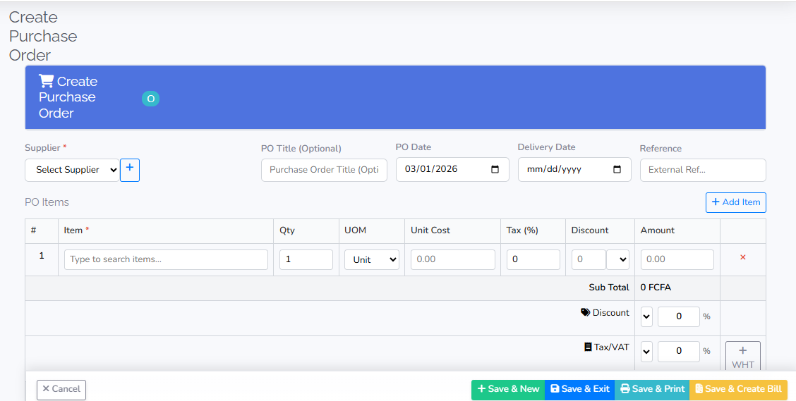

5.2 Goods Receipt
1 | When goods arrive, go to Operations > Goods Receipt — or open the PO and click Goods Receipt / Receive on the PO detail.

2 | Enter the received quantities per line. You can receive in multiple batches if the shipment is split.

3 | Confirm the receipt. Stock quantities are updated immediately.

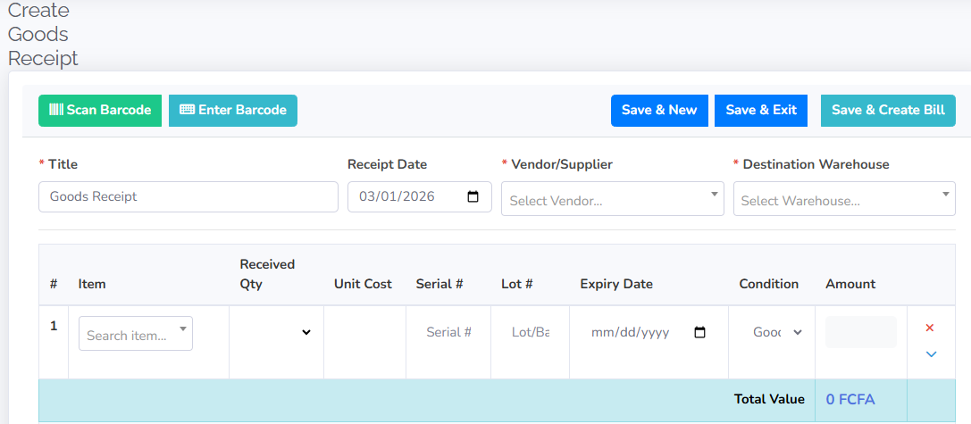

ℹ NOTE: After recording the Goods Receipt, create a Bill when the supplier's invoice arrives and match it to the PO for a complete purchase cycle
5.3 Bill of Material
Bill of material (BOM) is a comprehensive list that outlines all the raw materials component and assemblies required to produce a product.it entails total BOM, active BOM, approved BOM and average components
1 | In the sidebar, go to Operations and click Bill of material

2 | Click create BOM

3 | Fill in the required information

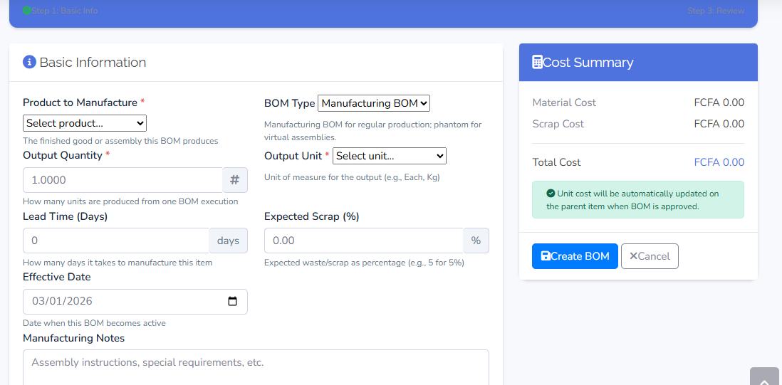

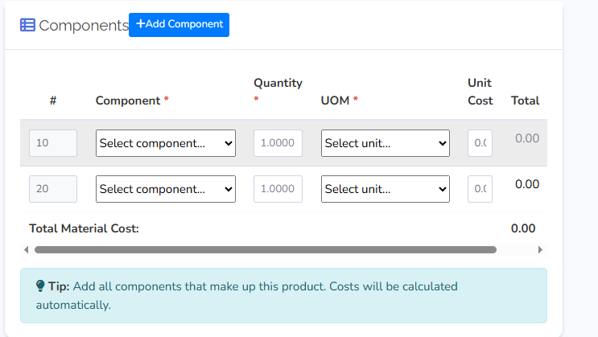

5.4 Inventory item
Inventory item refers to an item that a business holds for the purpose of resale or manufacturing
1 | In the sidebar, go to Operations and click Inventory item

2 | Click create new inventory item

3 | Fill in the required information

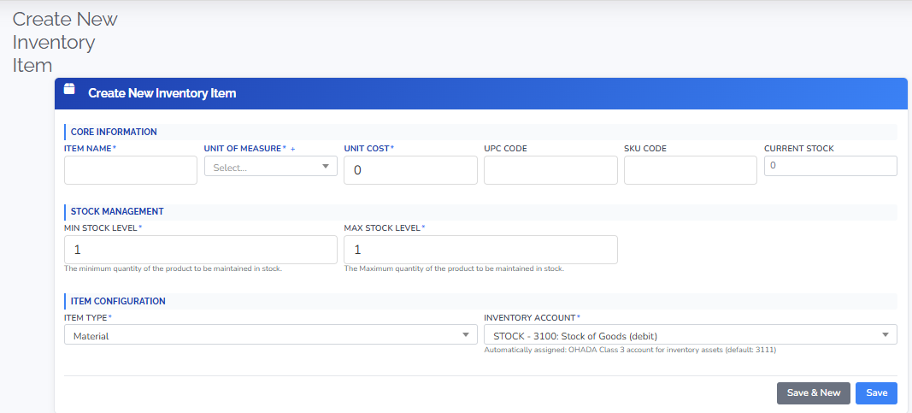

5.5 Stock Transaction
Stock transaction refers to the buying or selling of stock or shares of a company or organization.
1 | In the sidebar, go to Operations and click stock transaction

2 | Click add stock

3 | Fill in the required information

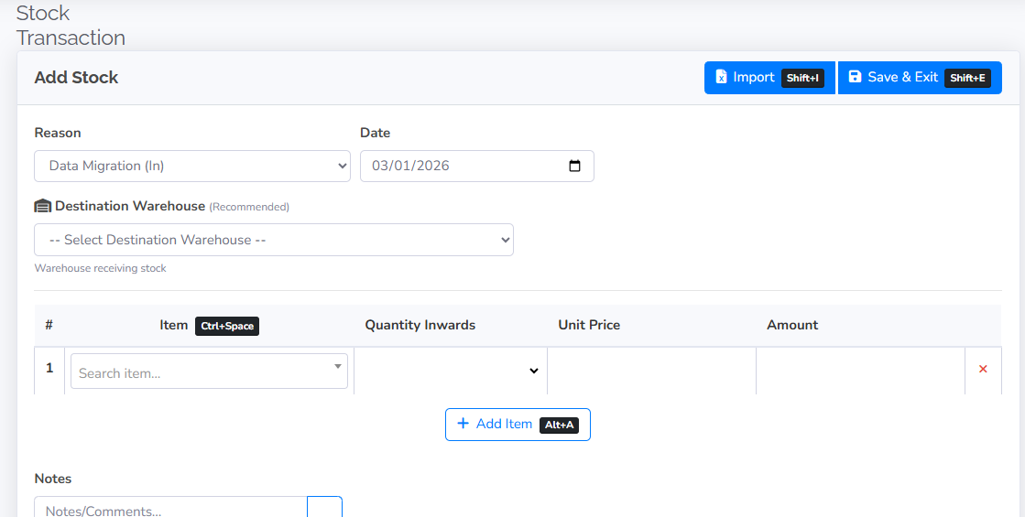

5.6 Warehouses
A warehouse is a physical location where good and inventory are stored before the are sold, distributed or manufactured. Warehouse bins are specific locations in a warehouse were designated items or inventory are kept.
1 | In the sidebar, go to Operations and click warehouse

2 | Click create new warehouse

3 | Fill in the required information
4 | Click on warehouse bin when you want to create a specific location for specific products

5 | Review totals. Click Save or Save Draft.

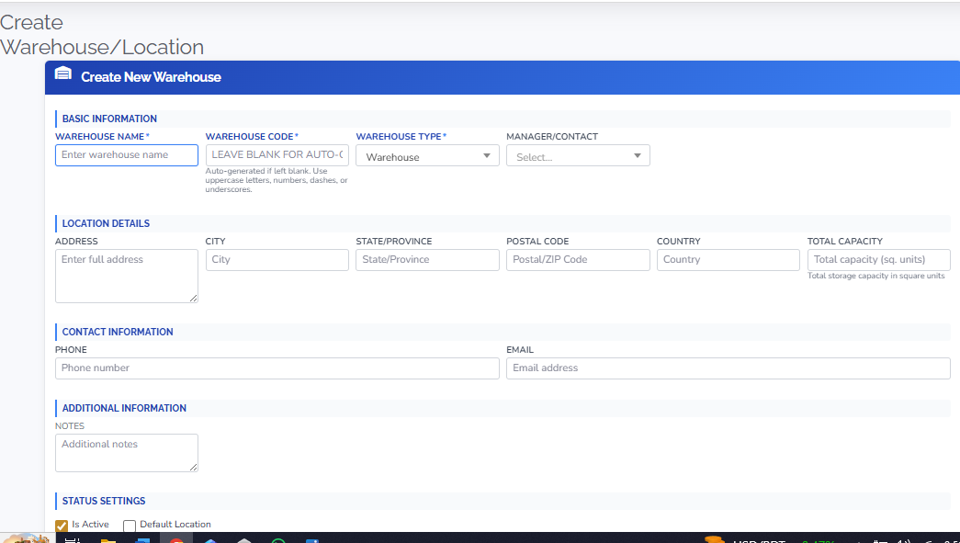

5.7 Service Projects
Service projects refers to specific initiatives or task undertaken by a business that provides services rather than physical goods such as Consulting, Construction or IT services
1 | In the sidebar, go to Operations and click Service Projects

2 | Click create or add a new project

3 | Fill in the required information
4
  Review totals. Click Save or Save Draft.

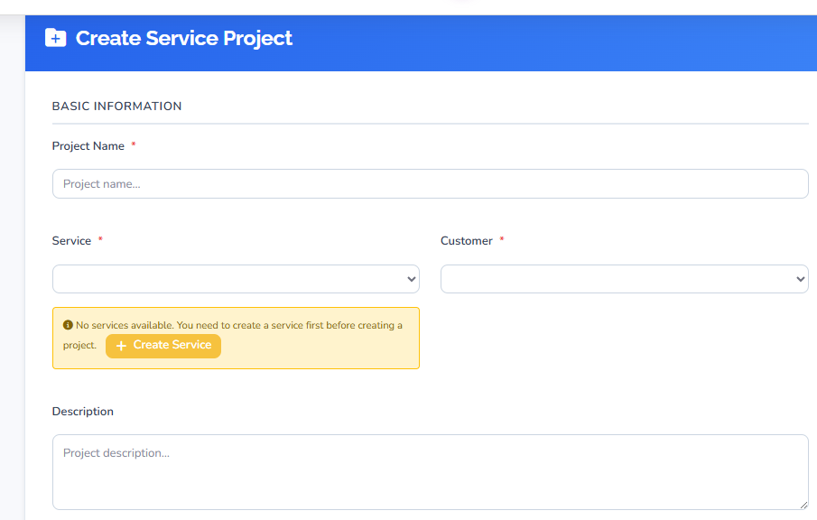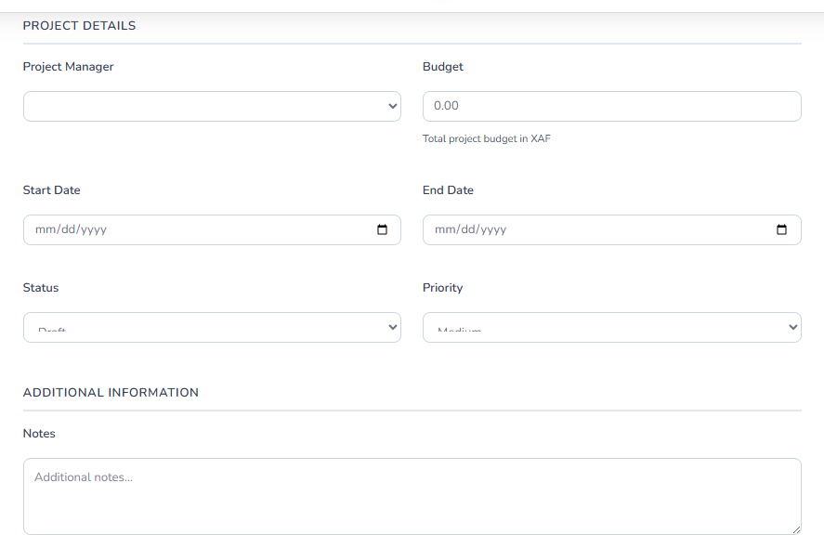

6. Inventory Management
This section covers Products, Services, Inventory Items, Categories, and Units of Measure. Access these from Inventory Management > Products & Items in the sidebar. Setting up products correctly keeps sales, purchases, and reporting accurate.

6.1 Products and Services
Before you begin: Decide whether the item is a Product (physical goods, optional quantity tracking) or a Service (no quantity). Have the name, sales price, and the income/expense accounts to use.

▶ SIDEBAR PATH: Inventory Management > Products & Items > Products (or Services)

Creating a Product or Service
1 | In the sidebar, expand Inventory Management, open Products & Items, then click Products for physical goods or Services for services.

2 | Click Create or Add Product (label may vary).

3 | Complete the basic details:

Field | Description
Name | What you call it (e.g., Widget A, Consulting Hour)
SKU | Unique stock-keeping unit code (optional but recommended for reporting and integration)
Description | Longer text that appears on invoices and purchase orders
Category | Product group for filtering — create under Products & Items > Categories first if needed
Unit of Measure | Each, Box, Kg, Hour, etc. — configure under Unit of Measures if needed

4 | Set pricing and accounts:

Field | Description
Sales Price | Default selling price
Purchase Cost | What you pay — used for cost of goods sold (COGS) and inventory valuation
Income Account | Revenue account credited when the item is sold (e.g., Sales – Products)
Expense Account | Cost account debited when sold (e.g., Cost of Goods Sold)
Inventory Account | Asset account for stock value (products with quantity tracking only)
Tax | Default tax rate applied to this item on invoices and bills

5 | For Products only — if the form includes inventory fields: enable Track Quantity, set Initial Quantity, Reorder Point, and Preferred Vendor/Supplier.

6 | Click Save or Save Draft.

💡 TIP: Use a consistent SKU format (e.g., category prefix + sequence: ELEC-001) so items sort predictably and are easy to filter in reports and pick lists.

6.2 Inventory Items, Categories, and Units of Measure
Item | Sidebar Path | What It Does
Inventory Items | Inventory Management > Products & Items > Inventory Items | Manage stockable items and their quantities. Use for items that are tracked in the warehouse.
Categories | Inventory Management > Products & Items > Categories | Create or edit product categories (e.g., Electronics, Raw Materials, Services) for filtering and reporting. Assign categories to products when creating or editing them.
Unit of Measures | Inventory Management > Products & Items > Unit of Measures | Create or edit units (Each, Box, Kg, Hour, etc.). Assign the appropriate UoM to each product.

6.3 Stock Management
Stock Management (under Inventory Management) includes Stock Transactions, Stock Reconciliation, Inventory Recount, and Goods Receipt for day-to-day stock operations. Use these when:

- Physical count differs from system quantity — Use Inventory Recount or Stock Reconciliation to investigate and correct discrepancies. Always document the reason.
- Receiving goods from a PO — Use Goods Receipt (also accessible from Operations > Goods Receipt) to record quantities received. Stock is updated on confirmation.
- Recording stock movements — Use Stock Transactions to see a full audit trail of every stock movement: receipts, shipments, adjustments, and transfers.

⚠ WARNING: Frequent or unexplained stock discrepancies may indicate receiving process gaps or security issues. Investigate before making corrections and document every adjustment clearly.

7. Money & Banking
This section covers Bank / Cash accounts, the Payment Dashboard, and Bank Reconciliation. Keeping bank records current and reconciled ensures an accurate cash position and supports month-end reporting.

7.1 Bank / Cash
Before you begin: Know the account's opening balance and the date it is from. Have the bank name and account type (checking, savings, cash, credit card).

▶ SIDEBAR PATH: Money & Banking > Bank / Cash

Adding a Bank or Cash Account
1 | In the sidebar, go to Money & Banking and click Bank / Cash.

2 | Click Add Bank Account (or Create Bank Account).

3 | Complete the form:

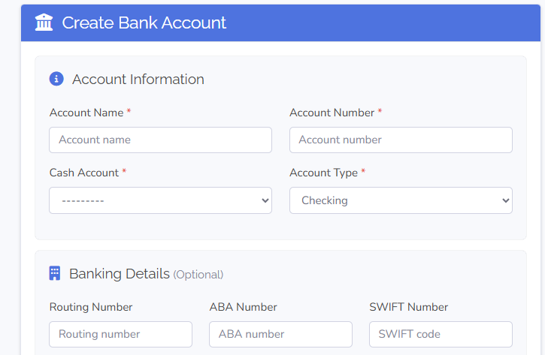

Field | Description
Account Name | Descriptive name shown in dropdowns (e.g., Main Checking, Petty Cash, Payroll Account)
Account Type | Checking, Savings, Credit Card, or Cash
Account Number | Last 4 digits only — do not store the full account number
Bank Name | Financial institution name
Opening Balance | Balance as of the opening date
Opening Balance Date | The date the opening balance is from
Currency | Account currency

4 | Click Save or Save Bank Account.

💡 TIP: Name accounts to match your bank's own account description (e.g., Chase Checking) to make reconciliation easier and reduce confusion.

7.2 Credit Note
A credit note reduces what a customer owes. Use it for returns, post-invoice discounts, or billing corrections. It reduces Accounts Receivable and Sales (and Tax Payable if applicable).

▶ SIDEBAR PATH: Money & Banking > Credit Note

1 | In the sidebar, go to Money & Banking and click Credit Note.

2 | Click Add Credit Note.

3 | Optionally link to the original invoice so the system can suggest amounts.

4 | Set Credit Note Date, Reference, and Reason (if required).

5 | Add line items with the amounts to credit.

6 | Click Save or Save Draft. Send to the customer if the option is available.

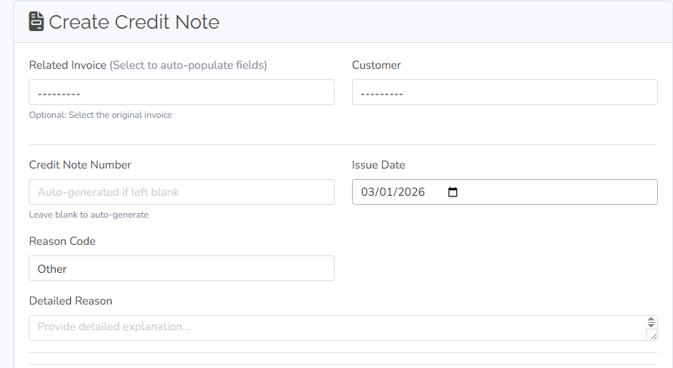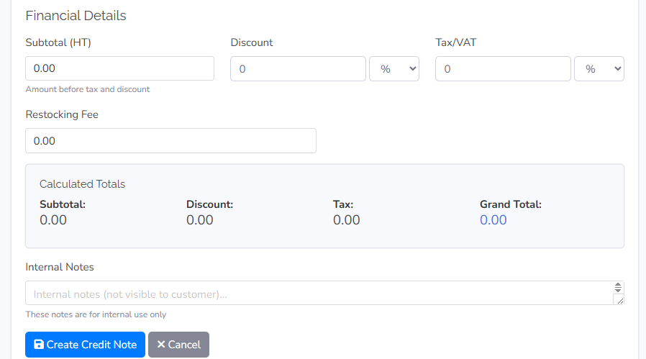

ℹ NOTE: To apply the credit to a future invoice or issue a cash refund, use the Apply to Invoice or Refund option on the credit note detail screen.

7.3 Receipt
The Receipt screen under Money & Banking lists all receipts (payments received from customers). Recording a payment on an invoice (via Add Payment on the invoice detail) creates the receipt automatically. Use Money & Banking > Receipt to view, search, and manage all receipts.

▶ SIDEBAR PATH: Money & Banking > Receipt
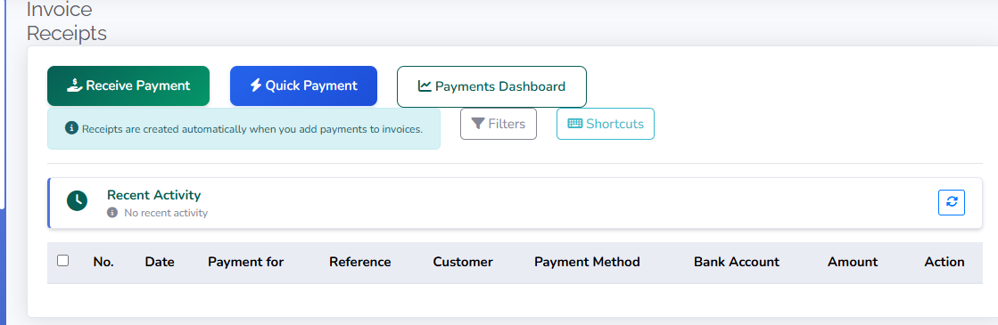

7.4 Debit Note
A debit note reduces what you owe to a supplier — used for returns, rebates, or billing corrections. It is the purchase-side equivalent of a sales credit note.

▶ SIDEBAR PATH: Money & Banking > Debit Note

1 | In the sidebar, go to Money & Banking and click Debit Note.

2 | Click Create or Add Debit Note.

3 | Optionally link to the original bill.

4 | Enter Date, Reference, and Line items. Click Save.

ℹ NOTE: To apply the debit note to a future bill or request a cash refund, use the Apply or Refund option on the debit note detail screen.

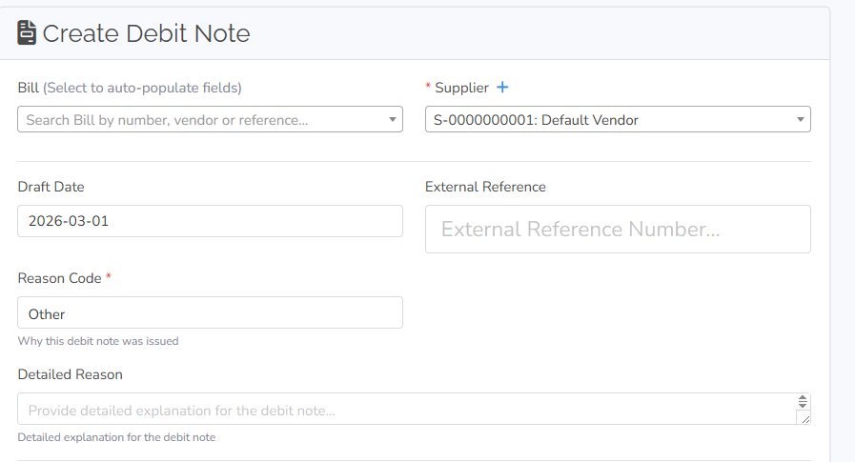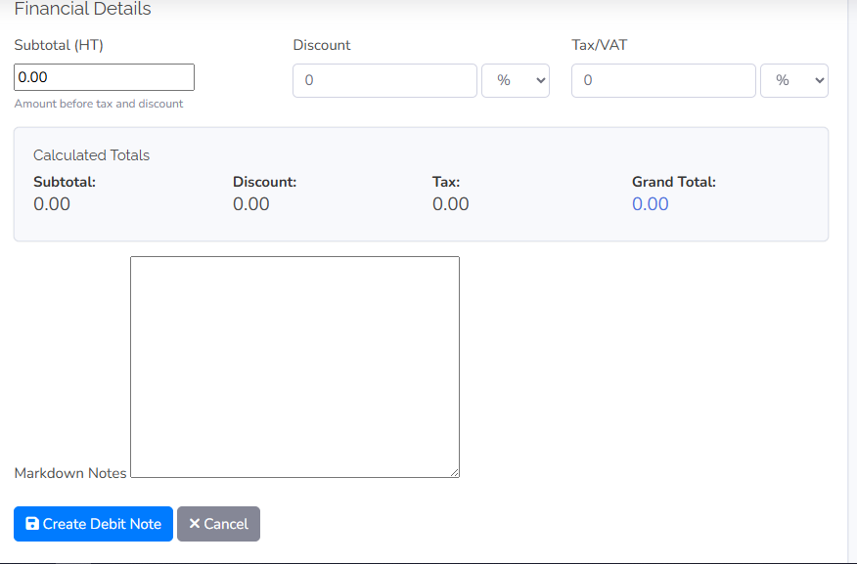

7.5s Payment Dashboard and Bank Reconciliation

Payment Dashboard
The Payment Dashboard (Money & Banking > Payment Dashboard) gives an overview of payments and cash flow: bills to pay, recent outgoing payments, and payment method summaries. Use it for a quick view of payables and to initiate bulk payments.

Bank Reconciliation
Bank Reconciliation matches every transaction in SOAS ERP to your bank statement so the book balance equals the bank balance and nothing is missing or duplicated.
Before you begin: Have your bank statement for the period. Note the statement end date and closing balance exactly as shown on the statement.

▶ SIDEBAR PATH: Money & Banking > Bank Reconciliation

1 | In the sidebar, go to Money & Banking and click Bank Reconciliation.

2 | Click Add Reconciliation (or Start Reconciliation). Select the Bank Account and enter the Statement Date and Ending Balance from the bank statement.

3 | For each transaction that appears on the bank statement, mark it as cleared. Leave transactions that have not yet cleared (e.g., outstanding cheques, deposits in transit) unchecked.

4 | If the bank statement shows a transaction not yet in SOAS ERP (e.g., a bank fee or interest charge), add it and mark it cleared.

5 | Watch the Difference figure: Cleared Balance minus Statement Ending Balance. Goal: Difference = 0.00.

6 | When Difference is zero, click Complete Reconciliation (or Finish). The period is locked.

Resolving Reconciliation Differences
Difference | Common Causes | Fix
Positive (book balance higher) | Duplicate deposit in books; withdrawal on statement not yet entered in system. | Check for duplicate transactions; add missing withdrawals.
Negative (book balance lower) | Fee or interest on statement not entered; cheque entered twice; wrong amount. | Add missing fees/interest; remove duplicates; correct amounts.

⚠ WARNING: Completed reconciliation periods cannot easily be undone. If you need to correct something after closing, add adjusting transactions and reconcile again in the next period.

Expense Payments
Expense Payments are managed under Expenses in the sidebar (Expense Payments, Payment Requests, Recurring Payments, Business Expenses). Record bill payments from the bill detail (Add Payment) or from Money & Banking > Payment Dashboard. Use Expenses for employee expense claims and reimbursements.

8. Reports & Insights
Reports & Insights provides financial statements, operational analytics, and an AI Assistant for plain-language queries. Run reports after data is entered and posted to monitor performance and prepare for tax filing.

▶ SIDEBAR PATH: Reports & Insights (sidebar)

8.1 Available Reports
Report | Sidebar Location | What It Shows | Primary Use
Balance Sheet | Reports & Insights > Balance Sheet | Assets, liabilities, and equity at a single date. | Assess net worth and financial position.
Income Statement | Reports & Insights > Income Statement | Revenue and expenses for a period — net profit or loss. | Monitor financial performance; required for tax.
Cash Flow Statement | Reports & Insights > Cash Flow Statement | Cash in and out by activity (operating, investing, financing). | Understand cash movements; plan for low-cash periods.
Trial Balance | Accounting & Setup or Reports | All account balances at a date (Debits = Credits). | Verify books are in balance before financial statements.
General Ledger | Accounting & Setup or Reports | Every transaction by account — full detail. | Drill down and audit specific entries.
AI Assistant | Reports & Insights > AI Assistant | Ask plain-language questions about your data. | Quick answers without building a report.
Analytics | Reports & Insights > Analytics | Interactive dashboard with charts and KPIs. | Monitor performance trends visually.

8.2 Running a Report
1 | In the sidebar, go to Reports & Insights and click the report you want (e.g., Balance Sheet, Income Statement, Cash Flow Statement).

2 | Set the date filter — Date for point-in-time reports or From / To for period reports.

3 | Select Entity if the report supports multi-entity selection.

4 | Choose Format or Options (e.g., Summary vs. Detailed) if available.

5 | Click Generate (or Run / Apply). Review results on screen.

6 | Click Export (if available) to download as PDF, Excel, or CSV.

💡 TIP: Always run the Trial Balance first. If Total Debits ≠ Total Credits, investigate and correct the imbalance before relying on the Income Statement and Balance Sheet.
ℹ NOTE: Some reports only include posted transactions. If figures appear missing, check whether relevant journal entries, invoices, or bills are still in Draft status and post them, then re-run the report.

8.3 AI Assistant
The AI Assistant (Reports & Insights > AI Assistant) lets you ask questions about your entity's data in plain language and receive answers instantly.

Example questions:
- "What were my top 5 expenses last month?"
- "Show me customers with invoices overdue by more than 30 days."
- "What is my gross profit margin this quarter compared to last quarter?"
- "List all unpaid bills over $1,000."

💡 TIP: Be specific about time periods and thresholds for the most accurate AI answers (e.g., 'last calendar month' rather than 'recently').

9. User Profile and Settings
Manage your personal profile and preferences from the user menu in the top-right corner of the application.

9.1 Accessing the User Menu
1 | Click your user icon or username in the top-right corner.

2 | The dropdown includes Profile, Settings, and Logout.

9.2 Profile
1 | Click Profile from the user menu.

2 | Update your Name, Email, and other profile fields as permitted.

3 | Save changes.

9.3 Settings
1 | Click Settings from the user menu.

2 | Adjust preferences such as dark mode, date format, default entity, and notification settings.

3 | Save. Preferences are stored for your user account.

9.4 Logging Out
1 | Click Logout from the user menu to end your session immediately.

💡 TIP: Always log out when using a shared or public computer to protect your account and entity data.

10. Troubleshooting
Use this section when something does not work as expected. Work through the checklist for the relevant issue. If the problem persists, see Section 10.5: Getting Support.

10.1 Can't Log In
Check | What to Do
Username and password | Re-enter carefully. Passwords are case-sensitive. Use Forgot Password if available.
Caps Lock | Ensure Caps Lock is off before typing.
Browser | Try a different browser or incognito/private window to rule out cached credentials or extensions.
Account locked | After multiple failed attempts the account may lock. Wait for the lockout period or ask your administrator to reset it.
Reset email not received | Check spam/junk. Add the sender to contacts. Request a new reset email from the login page.
SSO issue | Contact your IT administrator to verify your SSO configuration and group membership.

10.2 Transactions Not Balancing
Symptom: Trial Balance shows Total Debits ≠ Total Credits, or a report displays 'Out of balance'.

Check | What to Do
Unposted journal entries | Go to Accounting & Setup > Journals, filter by Draft status, and post or correct the entries.
Opening balances | Verify that your opening balance entry has equal debits and credits for the correct date. Fix and re-lock.
Recent transactions | Review the last few journal entries, invoices, bills, and payments for wrong account, wrong amount, or a missing line.
General Ledger | Run Trial Balance for the problem date. Find the account that looks wrong, then trace transactions in that account's General Ledger to locate the error.

💡 TIP: The account showing the imbalance is usually the last one that was edited. Start your investigation there.

10.3 Reports Showing Incorrect Data
Check | What to Do
Date range | Verify the From and To dates. An incorrect range is the most common cause of unexpectedly high or low figures.
Filters | Clear or adjust entity or other filters that may be excluding expected data.
Posted vs. draft | Most reports include only posted transactions. Post relevant drafts and re-run.
Account assignment | A transaction may have been posted to the wrong account. Correct the account on the transaction and re-run the report.

10.4 Inventory Quantities Incorrect
Check | What to Do
Stock Transactions | Go to Inventory Management > Stock Management > Stock Transactions. Review movement history for unexpected changes.
Unprocessed Goods Receipts | Confirm all PO Goods Receipts are confirmed in Operations > Goods Receipt. Unconfirmed receipts do not update stock.
Inventory Recount | Use Inventory Management > Stock Management > Inventory Recount to compare physical count to system count, then adjust with a clear reason.

10.5 Payment Not Recording
Symptom: You try to record a payment but the invoice or bill still shows unpaid, or the amount does not match.

Check | What to Do
Invoice/bill status | The document must be in an open or approved status. If already marked Paid, check for a duplicate payment already entered.
Amount | Payment amount cannot exceed the remaining balance. For partial payments, enter only the amount actually received or paid.
Bank account selected | A bank or cash account must be selected so the payment posts to the correct register.
Where to record | Payments are recorded from the invoice or bill detail page using Add Payment. Navigate to the specific invoice or bill and use that button — not the list view.

10.6 Getting Support
When you need assistance from your organization or vendor support team:

Channel | When to Use | What to Provide
Help Center / Knowledge Base | First stop for most issues | Search the error message or task name.
Support Ticket | Issues needing investigation | Entity name, username, what you were doing, what you expected, what happened, and any screenshots or error text.
Live Chat | Quick questions during business hours | Account and entity information ready.
Phone Support | Urgent or complex issues | Customer ID and a concise description of the issue.

Appendices

Appendix A: Account Types Reference
Type | What It Represents | Examples | Normal Balance | Statement
Asset | Resources owned by the business | Cash, A/R, Inventory, Equipment, Prepaid Expenses | Debit | Balance Sheet
Liability | Obligations owed by the business | A/P, Loans, Tax Payable, Long-term Debt | Credit | Balance Sheet
Equity | Owner's net interest | Share Capital, Retained Earnings, Owner's Drawings | Credit | Balance Sheet
Income | Revenue earned | Sales Revenue, Service Revenue, Interest Income | Credit | Income Statement
Expense | Costs incurred | Rent, Salaries, Utilities, Cost of Goods Sold | Debit | Income Statement

Appendix B: Key Sidebar Navigation Reference
Use this table to find any feature quickly by what you want to do.

Sidebar Module | Menu Item | What It Does
Quick Actions | Invoices | Create and manage customer invoices.
Quick Actions | Bills | Record and manage supplier invoices (Accounts Payable).
Quick Actions | Customers | Add and manage customer records.
Quick Actions | Suppliers | Add and manage supplier records.
Quick Actions | Products | Add and manage products for sale or purchase.
Money & Banking | Bank / Cash | Add and manage bank and cash accounts.
Money & Banking | Payment Dashboard | Overview of payables, recent payments, and cash flow.
Money & Banking | Receipt | View receipts (customer payments received).
Money & Banking | Credit Note | Issue credits against customer invoices.
Money & Banking | Debit Note | Reduce amounts owed to suppliers.
Money & Banking | Bank Reconciliation | Match book records to bank statements.
Operations | Purchase Orders | Create and track purchase orders to suppliers.
Operations | Goods Receipt | Record delivery of goods against a purchase order.
Operations | Stock Transactions | View full movement history for inventory items.
Operations | Warehouses | Manage warehouse locations.
Inventory Management | Products & Items > Products | Add and manage physical products.
Inventory Management | Products & Items > Services | Add and manage services (no quantity).
Inventory Management | Products & Items > Inventory Items | Manage stockable items and quantities.
Inventory Management | Products & Items > Categories | Define product categories for filtering.
Inventory Management | Products & Items > Unit of Measures | Define units (Each, Box, Kg, Hour, etc.).
Inventory Management | Stock Management > Inventory Recount | Compare physical count to system; adjust.
Reports & Insights | Balance Sheet | View assets, liabilities, and equity at a date.
Reports & Insights | Income Statement | View revenue and expenses for a period.
Reports & Insights | Cash Flow Statement | View cash receipts and payments by activity type.
Reports & Insights | AI Assistant | Ask plain-language questions about your data.
Reports & Insights | Analytics | Interactive charts and KPI dashboard.
Accounting & Setup | Chart of Accounts | Create and manage all accounts.
Accounting & Setup | Journals | Create and review manual journal entries.
Accounting & Setup | Tax Rates | Configure tax rates and rules.
Accounting & Setup | Closing Entries | Create and post period-end closing entries.
Accounting & Setup | Period Locks | Lock periods to prevent further entries.
Accounting & Setup | Budget | Set and monitor budgets by account.
My Entities | — | Switch between entities or create a new entity.

Appendix C: Glossary
Term | Definition
Accounts Payable (A/P) | Money your company owes to suppliers. A liability on the Balance Sheet.
Accounts Receivable (A/R) | Money that customers owe your company. An asset on the Balance Sheet.
Balance Sheet | Financial statement showing assets, liabilities, and equity at a single date.
Chart of Accounts (COA) | The complete list of all accounts used to record financial transactions.
Closing Entry | A journal entry made at period end to close revenue and expense accounts to retained earnings.
Credit | Right side of a double-entry transaction. Increases liabilities, equity, and income; decreases assets and expenses.
Debit | Left side of a double-entry transaction. Increases assets and expenses; decreases liabilities, equity, and income.
Debit Note | A purchase-side document reducing the amount owed to a supplier — the equivalent of a sales credit note.
Entity | One company or business unit in SOAS ERP. All data in the application belongs to the currently selected entity.
General Ledger (GL) | The complete record of every transaction by account — the authoritative source for all balances.
Goods Receipt | The record confirming physical arrival of goods ordered on a purchase order. Updates stock quantities.
Income Statement | Financial statement showing revenue and expenses over a period (also called Profit & Loss or P&L).
Journal Entry | A manual accounting entry with debit and credit lines. Total debits must equal total credits.
My Entities | The sidebar link (bottom) used to switch between entities or create a new one.
Post | To finalize a transaction so it updates account balances and appears on reports. Opposite of Draft.
Reconcile | To match book records to the bank statement so every transaction is accounted for and balances agree.
Supplier | A company you buy from. The app uses 'Suppliers' in the sidebar. Bills and Purchase Orders are linked to supplier records.
Trial Balance | A list of all account balances (debits and credits) at a date, used to verify the books are in balance.
UoM | Unit of Measure — how product quantities are expressed (Each, Box, Kg, Hour, etc.).

Appendix D: Best Practices
Practice | Why It Matters
Always verify the entity name in the header before entering data. | Records created in the wrong entity cannot be automatically moved.
Reconcile bank accounts monthly. | Catches missing transactions and errors early, before they compound.
Back up data regularly. | Protects against data loss. Use DB Backup (if available) or export critical data. Store backups securely.
Run Trial Balance before generating financial statements. | Ensures reports are based on balanced, accurate data.
Post transactions promptly — avoid leaving drafts. | Draft transactions are excluded from most reports, causing misleading figures.
Record payments on invoice/bill detail pages (Add Payment). | This is the correct workflow. Recording payments elsewhere may not link correctly.
Keep supporting documents attached to transactions. | Speeds up audits and helps resolve disputes with customers or suppliers.
Use strong passwords and review user access periodically. | Protects sensitive financial data from unauthorized access.

Appendix E: Maintenance Schedule
Frequency | Tasks
Daily | Record all sales and purchases. Record payments received and made. Confirm Goods Receipts for stock items. Update expense claims.
Weekly | Review Money & Banking > Payment Dashboard. Follow up on overdue invoices. Review cash position.
Monthly | Reconcile all bank accounts. Review Income Statement and Balance Sheet. Run month-end close (Closing Entries) if used. Generate tax-related reports.
Quarterly | Review budget vs. actuals (Accounting & Setup > Budget). Check tax accruals and payments. Perform inventory recount for key items.
Yearly | Run year-end closing entries. Generate final financial statements. File tax returns. Update Chart of Accounts as needed. Review and archive old data.

Appendix F: Learning Path for New Users
Day | Recommended Tasks | Sidebar Path
Day 1 | Log in, switch entity, create your first entity. | My Entities
Day 2 | Set up Chart of Accounts. Add a Bank / Cash account. | Accounting & Setup > Chart of Accounts; Money & Banking > Bank / Cash
Day 3 | Add a Customer and a Supplier. Create one Invoice and one Bill. | Quick Actions > Customers / Suppliers / Invoices / Bills
Day 4 | Record payments on Invoice and Bill detail pages. Run Bank Reconciliation. | Invoice/Bill detail > Add Payment; Money & Banking > Bank Reconciliation
Day 5 | Run Balance Sheet, Income Statement, and Trial Balance. | Reports & Insights; Accounting & Setup
Day 6 | Add Products and Services. Create a Purchase Order. Record a Goods Receipt. | Inventory Management; Operations
Day 7+ | Explore Reports & Insights > AI Assistant, Analytics, Accounting & Setup > Budget, Expenses. | Reports & Insights; Expenses

